RULES
The Tech Challenge 2016 (TTC 2016)
Building Excitement - Seismic Engineering in Action

CHALLENGE SCENARIO
In the last 40 years the population of California has almost doubled and the U.S. Census Bureau estimates that by 2025 its population will increase by 6 million people, all of whom need to be kept safe during earthquakes. Like many areas, the Bay Area, with its geographical limitations and close proximity to major fault lines, presents a great challenge for urban planners who need to accommodate more people while making sure buildings can withstand large earthquakes. Where do we put these people and how do we keep them safe?
The Challenge: Build an earthquake-safe structure!

THE CHALLENGE
Each TTC team will design and construct a scale structure (1/2" = 1') that supports live load and will be tested during a series of 20 second simulated earthquakes of changing movement. The testing time will be structured as follows: 20 second earthquake, 60 second repair period, 20 second earthquake, 60 second repair period, 20 second earthquake, final judging. Repairs will result in scoring deductions. Structure performance success will be judged based on three criteria: the structure does not fall over or collapse, major permanent damage does not occur, and the structure returns to its original position.
The test rig (earthquake simulator) that the teams will use to demonstrate their structures will be provided. It is a motor driven shake table that will move in an x axis. The test rig will have clamping devices to attach the baseplate of the team structure to the table. The shake table movement will be changed for each earthquake.
Judging criteria for the Engineering Process will include creativity, thought process, design and construction, teamwork, documentation, and adherence to the spirit of the challenge.

SPIRIT OF THE CHALLENGE
The Tech Challenge organizers have always emphasized to teams the importance of developing design solutions that would be practical in real life. TTC test rigs almost always involve small-scale replication of large scale, real world conditions. This is the case for TTC 2016. Teams should understand this scale difference, and they should attempt to develop designs which could be scaled up from TTC scale to full, real life scale. This scale-up ability would permit the team’s basic approach to make an effective contribution in real world situations. Tech Challenge entries that have this scale-up ability are said to have met “The Spirit of the Challenge.”
Compliance with “The Spirit of the Challenge” is an important factor influencing the judges’ assessment (and scoring) of TTC designs. The judges will ask teams about the real life practicality of their designs, such as “How would your design work in real life?” A good explanation of how their design approach is compatible with “The Spirit of the Challenge” will have a positive influence on the team’s score.

RULES
This section defines the rules that govern TTC 2016.
The design of the structure must be compatible with the rules outlined below. If the rules do not specifically prohibit a particular approach, then that approach is acceptable, provided it is safe.

STRUCTURE DESIGN RULES
- Design and build a scale (1/2" = 1 ft) structure that will survive multiple earthquakes.
- No materials are prohibited for use, as long they are safe, meet the structural dimension requirements, and meet the weight requirements. As part of the Spirit of the Challenge, teams will be asked how their building materials would scale or translate to real world structure design.
- The baseplate must be 20" x 20" +/- 1/4" in both directions. Where clamping to the test rig shake table will occur (2" perimeter described in #4), the baseplate thickness shall be 1/2" maximum.
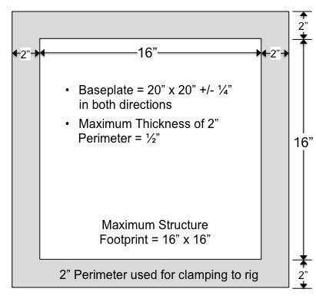
- The structure footprint cannot exceed 16" x 16" where it connects to the baseplate. This allows a minimum of two (2) inches around the perimeter of the structure for the baseplate to rig attachment (clamping). See Figure 1.
Figure 1: Baseplate Dimensions
- The maximum height of the structure is three (3) feet (36 inches) including the baseplate.

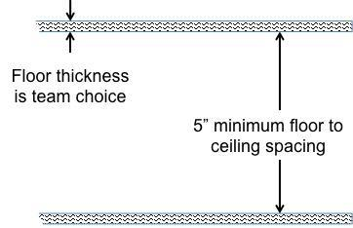
- The distance between each floor and the ceiling above is 5” minimum. See Figure 2.
Figure 2: Minimum Floor Spacing
- Individual rigid structural elements, other than flooring material, must fit into the following envelopes and are illustrated in Figure3 : 20" x 1/2" x 1/2" and/or a 3” diameter by 5” tall cylinder.

- Individual rigid structural elements may be fastened/adhered together to form longer/larger combined elements.
- The structure may not have walls.
- Structure decorations (if any) cannot hide construction details.
- The maximum weight of the structure is five (5) pounds, including the baseplate, but excluding added live load described below. Lower structural weight will positively impact score.
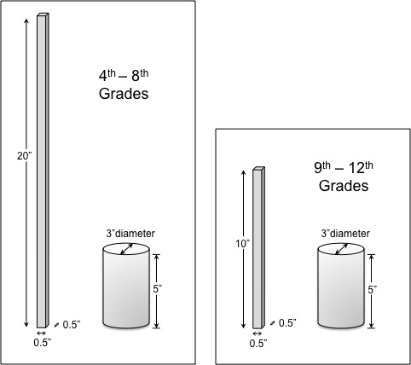
Figures 3 and 4: Rigid Structural Element Maximum Envelopes (Excluding Baseplate and Flooring)

- Floor space (area) should be maximized for the maximum height and design of the structure. The floor area must be calculated by each team using the rules listed below. The calculated floor space must be shared with judges and will be verified on event day.
- Floor space (area) is the total usable area of the structure, i.e. the sum of all the usable area of each floor including the base floor, but not including the roof.
- The area on each floor occupied by structural elements, i.e. vertical supports, structural tubes, stairways, etc., is not to be counted in the total structure area.
- Uncovered holes in the flooring are not to be counted in the total floor area, with the exception of holes filled with live load as described in #15 below.
- Structures with at least 1250 square inches of living/office (floor) area will be awarded the maximum number of points for this category. Structures with less than 1250 square inches of living/office (floor) area will be awarded points based on a sliding scale.
- Final calculated floor space must be written on the baseplate; detail calculations should be documented in team journal.

- Live load (weights) must be added by each team to their structure. The live load may either be built into the structure or added during the day of test trial/TTC. The number and distribution of the weights are defined in Table 1 below. Each weight is a 5/8 - 11 x 2" Hex Head Steel Zinc Machine Bolt and weighs approximately 3.5oz (98g) (see Figure 5).
Table 1: Number and Location of Weights Required
Grade | Minimum # of Weights* | Approximate Total Live Load
4th – 5th | 10 | 2.2 lbs (980 g)
* Placement is at the team's discretion with the following exceptions
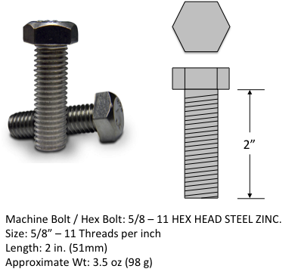
- Live load may not be placed on the base floor or roof
- No more than five (5) weights may be placed on a single floor
Figure 5: Live Load (Machine Bolt) Description
To allow for safe testing, easy installation and removal of the weights, 5/8" holes must be drilled into the floors and weights must be placed in the holes.
Bonus
- In keeping with the “Spirit of the Challenge” and acknowledging that buildings are realistically occupied on most floors, teams will gain bonus points by distributing their live load on at least 90% of the floors, not including the baseplate or roof.
- Teams that add more than the minimum live load (10), while still complying with the live load placement exceptions, will score bonus points.

PERFORMANCE RULES
There are two distinctly different time intervals involved when the teams are at the test rig. These two time periods are the setup time and the performance time.
Setup Period:
When the teams get to the test rig, there will be two-minutes of setup time during which the team members prepare for, but do not start testing their structure. The judges will tell the teams when this setup period starts and ends. During the two-minute setup time, the teams must comply with the following:
- The team will place and setup their structure on the test rig at their assigned time.

- Team members will clamp their structure to the rig shake table using only those clamps provided. It is the sole responsibility of the teams to make sure their structures are properly clamped.
- For safety reasons, the test rig will not be operated during setup.
Performance Period:
Each team will be given a three-minute period during which their structure will be tested in their attempt to meet the challenge. The three-minute performance period is structured as follows:
- 20 second earthquake
- 60 second repair period
- 20 second earthquake
- 60 second repair period
- 20 second earthquake
- Final judging

The judges will carefully control the time. The first 20 second simulated earthquake will start when the team says they are ready to begin or when the two-minute setup time has elapsed. During this three-minute performance period, the teams must comply with the following:
- Team members must remain inside the designated safety zone during earthquake simulation.
- Each team's structure will be subjected to three (3) simulated earthquakes described below. DBE stands for Design Base Earthquake.
- DBE 100% = 3” movement of the rig shake table (1.5” each direction) in a single axis
- DBE 200% = 6” movement of table (3.0” each direction)
- DBE 300% = 9” movement of table (4.5” each direction)
- The duration of each earthquake will be 20 seconds.
- Repairs will be allowed, but must be accomplished only during the 60-second periods between simulated earthquakes. Opting to repair a structure will be noted on the score sheet and will lead to deduction(s). Any material may be used to repair the structure as long as the material is safe and does not damage the rig (e.g. no duct taping to the rig).
- Judging Criteria for Success during earthquake simulation:
  - The structure does not fall over or collapse
  - Structure returns to its approximate original/vertical position
  - Major permanent damage does not occur (permanent means structural pieces fall off and/or damage cannot be repaired during the 60 second periods between earthquakes)

SAFETY RULES
Safety is the first priority.
- The structures shall not have features that are unsafe. The judges have full authority to stop any activity they view as unsafe. The judges’ word is final on all safety related issues.
- All members of the team must wear ANSI approved eye protection at all times when they are:
- In designated areas around the rigs
- Constructing their structure and/or doing at-home testing
Teams will not be allowed to participate at the trials or on event day unless all members of the team have the required eye protection. Eye protection will be available for students to borrow at supporting events and during the final competition for those who do not bring their own.
Note: Regular eyeglasses do not provide the necessary level of eye protection and will not be considered acceptable substitutes for ANSI approved eye protection.
- For safety, all team members must wear head protection. Students must bring their own helmets or hard hats to wear and are encouraged to wear head protection at all times during home testing. Bicycle helmets are acceptable.
- Teams are encouraged to identify a team member to be in charge of ensuring safe design, building, and testing of the structures. This person should be considered the team safety officer.

ENGINEERING JOURNAL
For The Tech Challenge, how teams develop their solution is as important as the solution itself. The engineering journal is a record of this process and is included in the scoring. It must be a detailed notebook, but does not need to be a typed report.
- Each team must submit one team journal. Team members are not required to keep individual journals, but are all encouraged to contribute to the team journal.
- The team’s journal is a living document and should be started at the beginning of the team’s involvement in the program. Organized records should be kept of all team activities.
- On event day, teams must submit a journal that is in the form of a binder or notebook containing multiple pages. Display boards, like those used for science fairs, or digital presentations can be a useful part of a team’s presentation but are not a substitute for an engineering journal.
- Journals may be typed, but handwritten journals are acceptable. Legibility is a key requirement.
For TTC 2016, the judges will be placing extra emphasis on safety issues. Team journals should describe how the design of their structures reflects consideration of safety issues. The judges will also be asking the teams how they handled safety during any at-home testing.
test rig with you and watch your p

